Can GParted Fix MBR in Windows

Can GParted Fix MBR in Windows 10, 8, 7? Here is the Answer!
If you are wondering whether GParted can fix MBR in Windows PC, read this post to find the answer. Here we will introduce possible ways to repair Windows MBR step by step.

By Emily / Last Updated August 28, 2020
- When do you need to fix MBR?
- Can GParted fix MBR in Windows computer?
- Tutorial: Use GParted Live to fix MBR in Windows 10, 8, 7
- Free alternative to GParted Live: fix MBR more easily
- Summary

When do you need to fix the MBR?
MBR (Master Boot Record) is the most important sector of the drive and located at the beginning of the drive that identifies the OS location and allows OS to boot successfully. It informs the boot process as to what is about to follow, such as partition layouts, sizes, file systems, and more. Briefly, MBR decides if the Windows can boot up smoothly.
Therefore, when your system fails to boot into Windows and is stuck with a screen with various error messages reporting “Missing operating system,” “MBR error,” “Error loading operating system,” “Invalid partition table,” or similar, there is a very strong chance that the MBR is damaged for some reasons and needs to be repaired.

Can GParted fix MBR in Windows computer?
GParted is a free partition editor for graphically managing your disk partitions. It can be used on x86 and x86-64 based computers running Linux, Windows, or Mac OS X by booting from media containing GParted Live. It allows you to can create, delete, resize, move, copy partition and so on.
Then, you might wonder if you can use GParted to fix MBR in Windows PC. As a matter of fact, GParted does not have the feature to fix MBR. But the GParted Live can help you make a bootable media for booting your computer and using TestDisk to fix Windows MBR.
Note: GParted is the partition editor application. GParted Live is a small bootable GNU/Linux distribution that contains the free partition editor application.

Tutorial: Use GParted Live to fix MBR in Windows 10, 8, 7
First of all, please download the GParted Live. There will be 2 versions for your selection. For 32-bit system, choose the i686.iso version. For a 64-bit system, download the amd64.iso one.
Secondly, write the disc image to a bootable device (a USB flash drive, a CD, or a DVD). For this task, you can use Tuxboot to install GParted Live on your USB flash drive. Download the tuxboot file. Run the exe file, select an ISO file or a distribution to download, select a target drive (USB Drive or Hard Disk), then reboot once done.
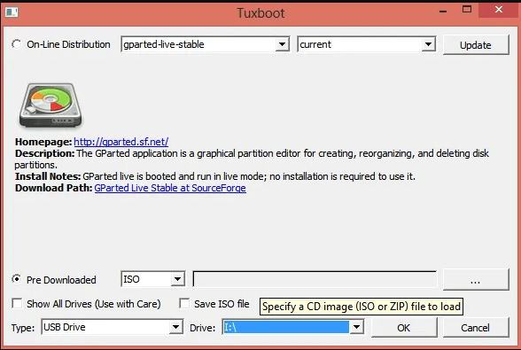
Thirdly, insert the bootable GParted Live media into the system with a corrupt MBR. Power on the machine and press the appropriate button (usually F1, F2, F8, F9, F12, ESC, or backspace) during the OS initiation to get to the BIOS boot menu and change the startup order to boot USB by default.
Boot computer from the GParted Live media. Make a few selections, such as the language and operational mode. Then follow the steps to learn how GParted Live fix MBR in Windows PC.
Step 1. Once the GParted Live environment loads, open a Terminal window by double clicking on the terminal icon on the desktop, type “sudo fdisk –l” and press Enter to list all drives and partitions available on your system now.
Step 2. Open a new Terminal window, type “testdisk”, then select “No Log”.
Step 3. Select the disk with corrupted MBR, then “Proceed”.
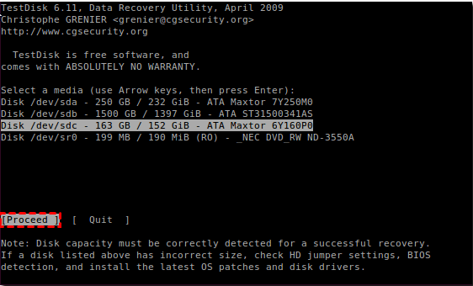
Step 4. Select the partition table type. Here we select “Intel/PC partition”, and press Enter.
Step 5. To write a new MBR on the disk, select “[ MBR Code ] Write TestDisk MBR code to first sector”.
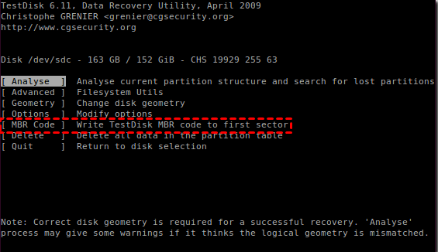
If the system still won’t boot, you can try to repair the boot sector of the boot partition.
1. Start testdisk again, select the “No log” option and select your Disk where Windows is installed. Do the same steps as above. Choose “[Advanced] Filesystem Utils”.
2. Then select the boot partition and choose [boot] Boot sector Recover. Following by option “[Rebuild BS] Rebuild boot sector”.
This will write the new sector to disk. From the steps, we can know that it is not GParted, but the TestDisk that fixes MBR. The GParted Live can just be regarded as an assistant tool.

Free alternative to GParted Live: fix MBR more easily
Now that the answer to “can GParted fix MBR” is negative. Then we would like to introduce a free partition manager called AOMEI Partition Assistant Standard. It has the “Rebuild MBR” feature, which can easily repair damaged MBR in Windows 10/8/7/XP/Vista (either 32-bit or 64-bit). To repair MBR in Server computer, try the Server Edition. Below is how to fix MBR step by step:
Preliminary work:
①Prepare a USB flash drive to make a bootable media, and back up crucial data because the process will erase everything on the USB drive.
②Connect the USB to a working Windows computer because the damaged MBR leads to your PC boot failure. Download the freeware and install it on the computer as well.
Download Freeware
Win 10/8.1/8/7/XP
Secure Download
Step 1. Launch AOMEI Partition Assistant Standard. Click “Make Bootable Media” on the left panel.
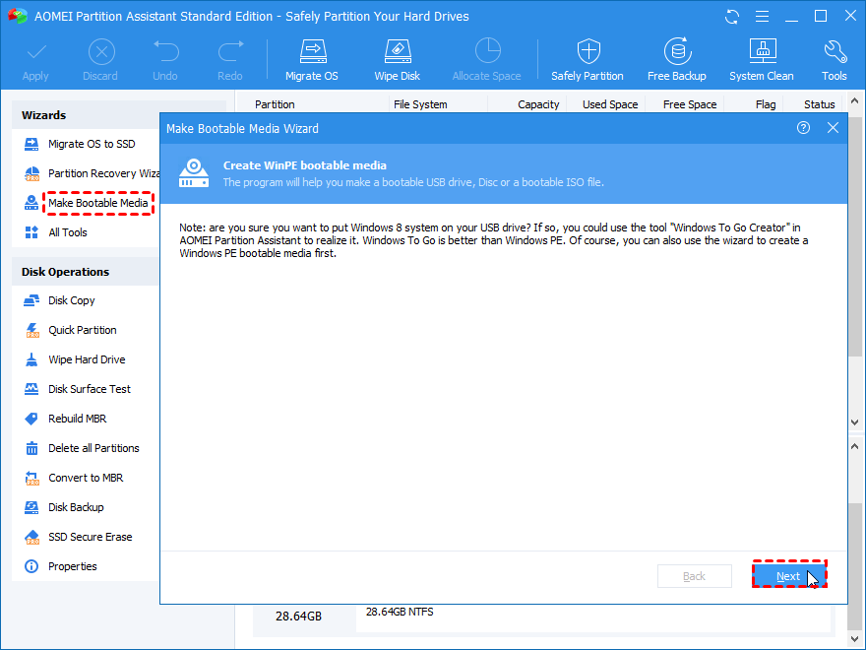
Step 2. Tick “USB Boot Device” and select the inserted USB drive. Click “Proceed”.
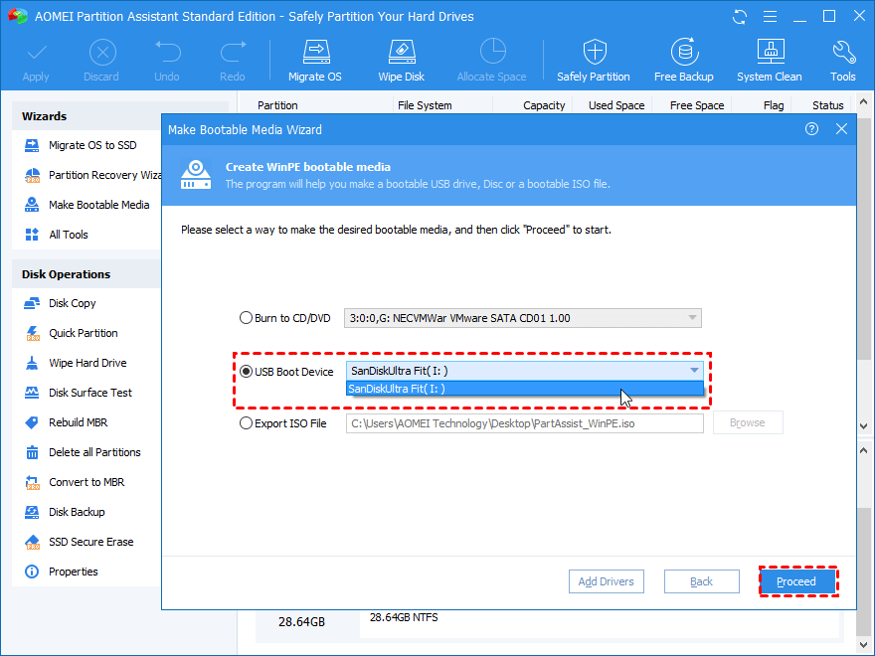
Step 3. Wait for the process to be accomplished. The bootable USB will contain preinstalled AOMEI Partition Assistant Standard then.
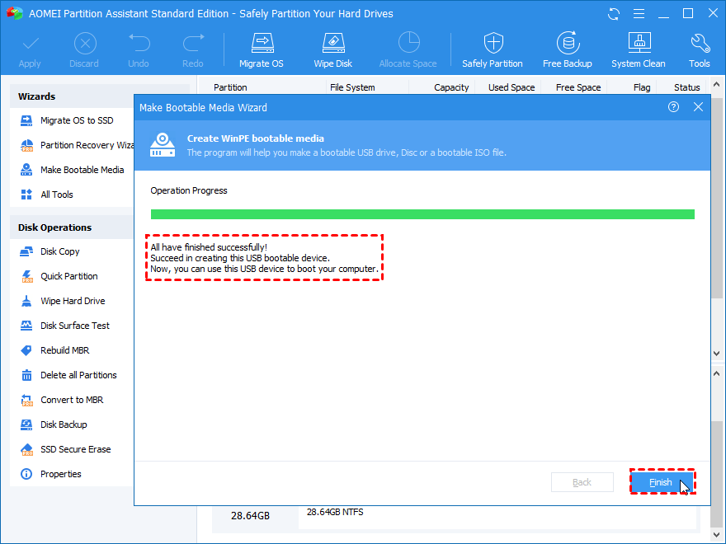
Step 4. Unplug the bootable USB from the working computer and insert it into the PC which cannot boot up due to corrupted MBR. Change boot order to boot computer from the USB drive.
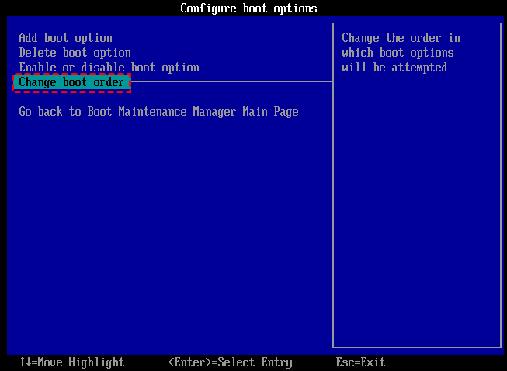
Step 5. Once login, the AOMEI Partition Assistant Standard will run automatically. Then right click the target disk and select “Rebuild MBR”.
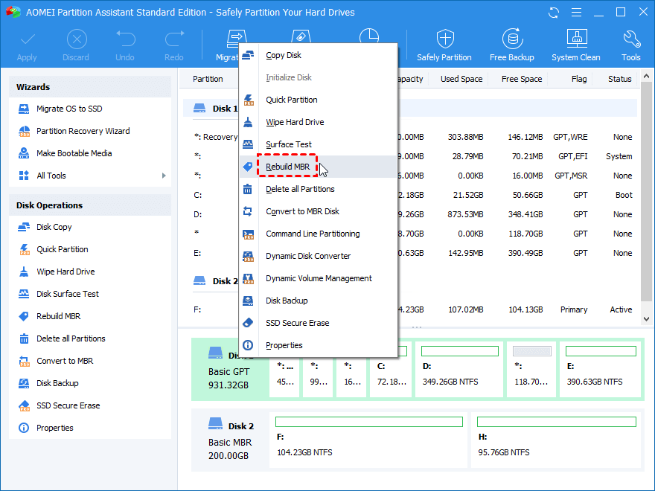
Step 6. Select the proper MBR type for your current OS and click “OK”.
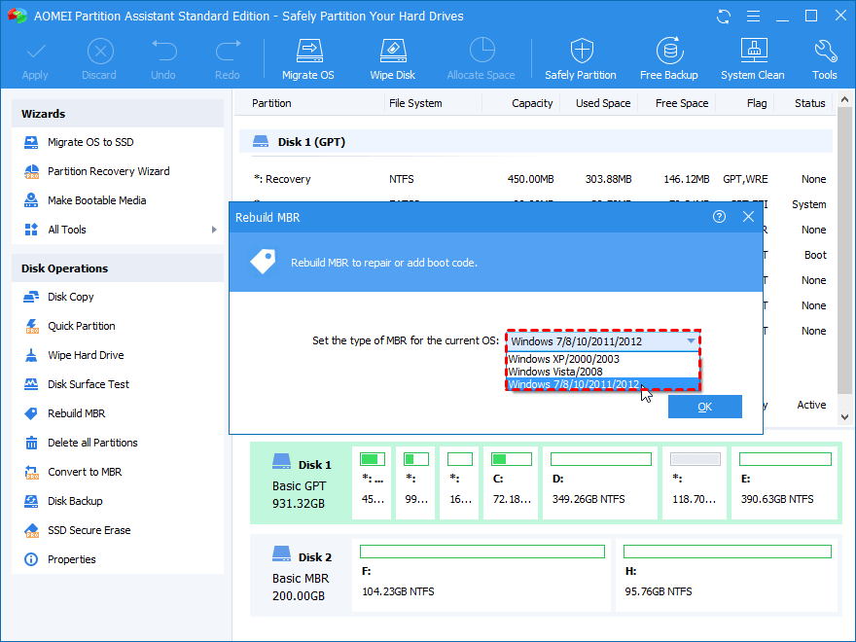
Step 7. Click “Apply” and “Proceed” to commit the pending operation.
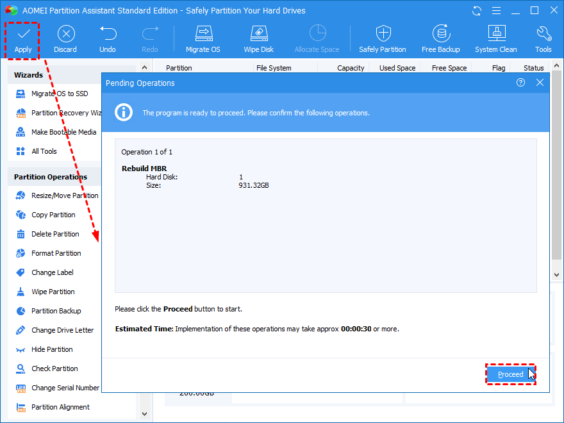
After it is done, you can remove the bootable media and try to reboot your Windows.

Summary
This post not only explains whether you can use GParted to fix MBR, but also shares an easier way to finish this task in Windows 10, 8, 7. The recommended freeware can do more than just rebuilding MBR. For example, it is capable of copying MBR from one disk to another one, converting data disk from/to MBR without deleting partitions, migrating OS to SSD, and more.
https://www.diskpart.com/articles/gparted-fix-mbr-7201.html

